ANDROID APP DEVEPLOMENT

PROJECT REPORT

On

Chat Application

Submitted to Centurion University of Technology& Management
in partial fulfillment of the requirement for award of the degree of

B. TECH.

in

COMPUTER SCIENCE & ENGINEERING

Submitted By
Group Member:-
Hariom Kumar (220101120036)

Under the Guidance of

Dr.Dhawaleswar Rao



DEPT. OF COMPUTER SCIENCE & ENGINEERING

SCHOOL OF ENGINEERING &TECHNOLOGY,
CUTM, Paralakhemundi-761211

CERTIFICATE


This is to be certified that the minor project entitled “Chat Application” has been submitted for the Bachelor of Technology in Computer Science & Engineering of School of Engineering & Technology, CUTM, Paralakhemundi during the academic year 2023-2024is a persuasive piece of project work carried out by “HARIOM KUMAR(220101120071) towards the partial fulfillment for award of the degree (B.Tech.) under the guidance of “Dr.Dhawaleswar Rao” and no part thereof has been submitted by them for any degree to the best of my knowledge.

Signature of Student Signature of Project Guide
Name of the Student Name of the Guide
Dr.Dhawaleswar Rao

EVALUATION SHEET
- Title of the Project: CHAT APPLICATION
- Year of submission: 2024
- Name of the degree: BTech (CSE)
- Date of Examination / Viva:
- Student Name with Regn No.: HARIOM KUMAR(220101120071)

- Name of the Guide: Dr.Dhawaleswar Rao
- Result:
[APPROVED/REJECTED]

Signature of HOD Signature of Project Guide
Name of the HOD Name of the Guide
Dr.Dhawaleswar Rao Signature of External Examiner

ACKNOWLEDGEMENT
We “Hariom Kumar” , B.Tech. in CSE (Semester- IV) of School of Engineering &Technology, CUTM, Paralakhemundi, hereby declare that the Project Report entitled “Chat Application” is an original work and data provided in the study is authentic one. This report has not been submitted to any other Institute for the award of any other degree by me.

Signature of Student

Abstract

Communication through internet is becoming vital these days. An online communicationallows the users to communicate with other people in a fast and convenient way.Considering this, the online communication application must be able share the texts orimages or any other files in a faster way with minimum delay or with no delay. Firebaseis one of the platforms which provides a real-time database and cloud services which allowsthe developer to make these applications with ease. Instant messaging can be considered asa platform to maintain communication. Android provides better platform to developvarious applications for instant messaging compared to other platforms such as iOS.The main objective of this paper is to present a software application for the launching ofa real time communication between operators/users. The system developed on androidwill enable the users to communicate with another users through text messages with thehelp of internet. The system requires both the device to be connected via internet. Thisapplication is based on Android with the backend provided by google firebase.

In the realworld the communication plays a very vital role. People have been communicating witheach other through various applications or mediums. In the beginning peoplecommunicated with each other using letters or other sources, as these mediums could takemuch time to deliver the content. Cell phones are another medium of communication but thedrawback is for any limited or small message which need to be passed to another user then phone call is not an ideal way. The developers then looked to implement a text-basedcommunication which would allow an in instant communication service.

The basic goalis to create a system which can create chatroom according to the users and store the relateddata at a single place. To implement the real time chatting application which can allow theuser to make instant group messages. Implementing google firebase cloud and real timedatabases to store the data. It is an internet based instant messaging application which provides the user to communicate with other users in a fast and convenient way . Both thedevices must have an active internet connection for the communication. There are manyother chat applications like WeChat, hike, WhatsApp, Telegram, Facebook messenger,Snap Chat, Line etc but in this system the pdf creation and pdf reading feature will beincluded. As a part of day to day life, academic or professional life users need to sendand receive files.

INDEX:

Sno | Topic | Range of the Page Number
1. | INTRODUCTION | 7
2. | REQUIREMENT SPECIFATION | 8
3. | SYSTEM REQUIREMENTS | 9
4. | DEVELOPMENT ENVIROMENT | 10
5. | SYSTEM DESIGN | 11
6. | SYSTEM IMPLEMENTION | 12 to 13
7. | SAMPLE OUTPUT | 14 to 16
8. | CONCLUSION | 17 to 18
9. | REFERENCES | 20

INTRODUCTION

The project titled “Chat Application” is messaging application for sending messages.
In the real worldthe communication plays a very vital role. People have been communicating with each otherthrough various applications or mediums. In the beginning people communicated with each otherusing letters or other sources, as these mediums could take muchtime to deliver the content. Cell phones are another medium of communication but the drawback is for any limited or smallmessage which need to be passed to another user then phone call is not an ideal way. Thedevelopers then looked to implement a text-based communication which would allow an ininstant communication service. In 1984, the concept of SMS was developed in the FrancoGerman GSM cooperation by Friedhelm Hillebrand and Bernard Ghillebaert. The limitation ofSMS was the limited size i.e., 128 bytes, after the rise of smartphones from a decade manymessaging applications have been developed. Some are Bluetooth based and some were internet based such as WhatsApp, WeChat and others. Android is an operating system for mobileswhich was developed by google.This operating system allows the applications to be used onmobiles. As it was developed by google, android users can develop mobile applications and can be sold through android application stores such as play store. Firebase is a NoSQL database whichmake use of sockets which allows the users to store and retrieve the data from the database . AnAndroid version should be greater than 2.3, android studio 1.5 or higher version, and android studio project are the prerequisites to connect the firebase to an android application. Firebase providesa various kind of services such as: Firebase Authentication: Firebase Authentication is usefulto both developers and the users. Developing and maintaining sign-in set-up may be a bitdifficult and time taking. Firebase provides an easy API for sign in. It also provides the data backup using real time databases. Firebase cloud: For storing the data such as video, text, pictures building the infrastructure would be difficult and expensive for a new developer so the firebase provides the platform of cloud storage. Real time database: It is a cloud hosted NoSQL database.Apart from the authentication, cloud service and real time databases firebase also provides aservice for crash reporting Crash Reporting: when some unexpected crashes occur in anyapplications it may be difficult to conclude why the application crashed. Firebase providescrash reporting service to deal with these crashes. This paper is concerned of a softwareapplication for the establishment of a real time communication services between operators/users.Chat application many-to-many type of communication system where the users will able toexchange the messages among themselves.

Android

Android is a mobile operating system (OS) currently developed by Google, based on the Linuxkernel and designed primarily for touchscreen mobile devices such as smartphones and tablets.Android's user interface is mainly based on direct manipulation, using touch gestures that looselycorrespond to real-world actions, such as swiping, tapping and pinching, to manipulate on-screen objects, along with a virtual keyboard for text input. In addition to touchscreen devices,Google has further developed Android TV for televisions, Android Auto for cars, and AndroidWear for wrist watches, each with a specialized user interface. Variants of Android are also usedon notebooks, game consoles, digital cameras, and other electronics. Initially developed byAndroid, Inc., which Google bought in 2005, Android was unveiled in 2007, along with thefounding of the Open Handset Alliance
–
a consortium of hardware, software, andtelecommunication companies devoted to advancing open standards for mobile devices. As ofJuly 2013, the Google Play store has had over one million Android applications downloaded. Anapplications ("apps") published, and over 50 billion April
–
May 2013 survey of mobileapplication developers found that 71% of developers create applications for Android, and a 2015survey found that 40% of full-time professional developers see Android as their priority target platform.

About 70 percent of Android smartphones run Google's ecosystem; some with vendor-customized user interface and software suite, such as TouchWiz and later One UI by Samsung,and HTC Sense. Competing Android ecosystems and forks include Fire OS (developed byAmazon) or LineageOS. However the "Android" name and logo are trademarks of Google whichimpose standards to restrict "uncertified" devices outside their ecosystem to use Android branding.

Android has been the best-selling OS worldwide on smartphones since 2011 and ontablets since 2013. As of May 2021, it has over three billion monthly active users, the largestinstalled base of any operating system, and as of January 2021, the Google Play Store featuresover 3 million apps.The current stable version is Android 11, released on September 8, 2020.

Project Aims and Objectives

The basic goal is to create a system which can create chatroom according to the users and storethe related data at a single place. To implement the real time chatting application which canallow the user to make instant group messages. Implementing google firebase cloud and realtime databases to store the data.

It is an internet based instant messaging application which provides the user to communicate with other users in a fast and convenient way . Both thedevices must have an active internet connection for the communication. There are many otherchat applications like WeChat, hike, WhatsApp, Telegram, Facebook messenger, Snap Chat,Line etc but in this system the pdf creation and pdf reading feature will be included. As a partof day to day life, academic or professional life users need to send and receive files.

METHODOLOGY

This project is made by using Android studio, Virtual emulator. The programming languages usedfor building the application are Java, XML.User interface is handled using XML codes. Backend programming is handled mainly through setof java codes.The other libraries required are:

Android SDK tools
Android SDK platform tools
Android SDK build tools
SDK platform
Intel x86 Atom_64 System Image
Google APIs
Google APIs ARM EABI v7a System Image
GPU Debugging tools
Android Support Library
Intel x86 Emulator Accelerator (

REQIREMENT SPECIFICATION

- SYSTEM REQUIREMENTS

1.Hardware Configuration
1. Intelcorei3 or above
2.Ram: 1GB
3. Hard disk: 20GB

2.Software Configuration
1.Operating System - Server: Windows , Client: Android 4.0 or higher
2.Development Environment - Server side : Eclipse , Client side : Android Studio
3. Java runtime environment - Java version: jdk
4. Data Base - MY SQL

DEVELOPMENT ENVIRONMENT

Software Development Kit (SDK)
A software development kit (SDK or "devkit") is typically a set of software developmenttools that allows the creation of applications for a certain software package, softwareframework, hardware platform, computer system, video game console, operating system, orsimilar development platform. To create applications you have to download this softwaredevelopment kit. For example, if you want to create an Android app you require an SDK with java programming, for iOS apps you require an iOS SDK with swift language, and to developMS Windows apps you require the .net language. There are also SDKs that are installed in appsto provide analytics and data about activity. Prominent examples include Google and Facebook.

Android studio
Android Studio is an integrated development environment (IDE) for developing for the Android platform. It was announced on May 16, 2013 at the Google I/O conference. Android Studio isfreely available under the Apache License 2.0. Android Studio was in early access preview stagestarting from version 0.1 in May 2013, then entered beta stage starting from version 0.8 which wasreleased in June 2014. The first stable build was released in December 2014, starting from version1.0. Based on JetBrains' IntelliJ IDEA software, Android Studio is designed specifically forAndroid development. It is available for download on Windows, Mac OS X and Linux, andreplaced Eclipse Android Development Tools (ADT) as Google's primary IDE for native Androidapplication development.

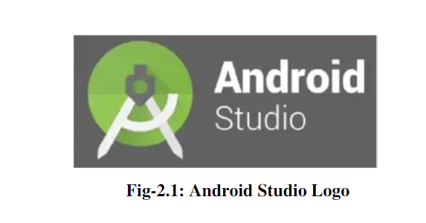

SYSTEM DESIGN

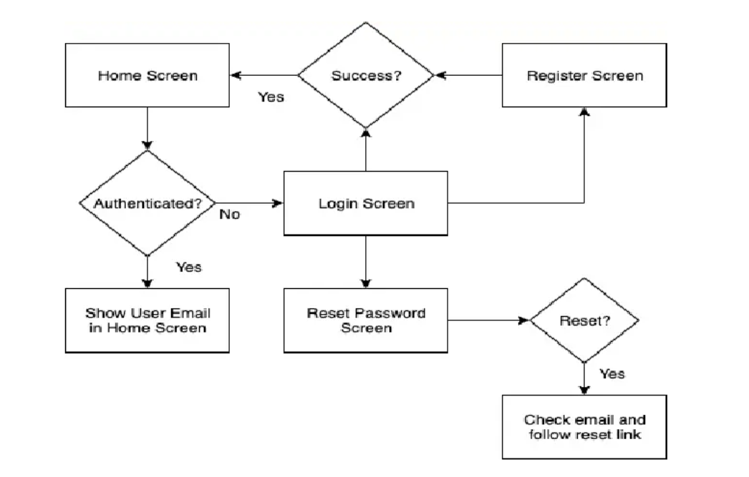

1.SIGN IN
The user must register in order to login, the user must login in order to send messages to thosewho are online, and must be able to logout if the user wants to logout.

2. LOGIN IN
After signing in or registering, the user must login in with the registered mail-id and password.On successful login the user enters into his/her profile.

3. PASSWORD RESETTING
If the user fails to remember the password during loging in ,the user can go for the option forgot password. During which the user is required to enter the email-id to which the password resetlink will be sent.

4. ONLINE MENU
After the client is logged in, the client can choose to send a message, only if anotherclient is online, check who is online, and be able to logout when the client wants to,which will be by logging out by hitting the logout button or by hitting the exit button.

- USERS
When the client wants to see who is online, the client clicks the “users” menu
and the client canchoose who to message, by double clicking the name.

6. MESSAGE
When the client wants to message the user, the client clicks on the name, the user can send amessage to another online user. Some character limitations for typing might be put into place,only if it is necessary.

7.LOG OUT
The user can logout whenever he wants by clicking on the logout option in the top right corner,which takes back the user back to the register page.

Code:
<!DOCTYPE html>
<html lang="en">
<head>
<meta charset="UTF-8">
<meta http-equiv="X-UA-Compatible" content="IE=edge">
<meta name="viewport" content="width=device-width, initial-scale=1.0">
<link rel="stylesheet" type="text/css" href="https://cdnjs.cloudflare.com/ajax/libs/font-awesome/6.4.0/css/all.min.css">
<link rel="stylesheet" type="text/css" href="style.css">

<link rel="stylesheet" href="https://cdn.jsdelivr.net/npm/swiper@9/swiper-bundle.min.css" />

<title>Online Restaurant Website</title>
</head>
<body>

<header>
<a href="#" class="logo"><img src="./navbar/logo.png"</a>

<nav class="navbar">
<a href="#home" class="nav-item active">home</a>
<a href="#about" class="nav-item active">about</a>
<a href="#menu" class="nav-item active">menu</a>
<a href="#team" class="nav-item active">team</a>
<a href="#reservation" class="nav-item active">reservation</a>
<a href="#blog" class="nav-item active">blog</a>
</nav>

<div class="icons">
<i class="fa-solid fa-bars icon"></i>
<i class="fa fa-search icon"></i>
<i class="fas fa-heart icon"></i>
<i class="fas fa-shopping-cart icon"></i>

</div>
</header>

<div class="home" id="home">
<div class="swiper home-slider">
<div class="swiper-wrapper wrapper">
<div class="swiper-slide slide slide1">
<div class="content">
<img src="./navbar/crown-symbol.png">

<h3>Delicious Royate</h3>
<h1>Gift Voucher</h1>
<p>
give away your beloved customers
</p>
<a href="#" class="btn">Order Now</a>
</div>
</div>

<div class="swiper-slide slide slide2">
<div class="content">
<img src="./navbar/crown-symbol.png">

<h3>sale off 10% this dish</h3>
<h1>the fresh</h1>
<p>
food restaurant
</p>
<a href="#" class="btn">Order Now</a>
</div>
</div>

<div class="swiper-slide slide slide3">
<div class="content">
<img src="./navbar/crown-symbol.png">

<h3>we are open</h3>
<h1>fresh fruits</h1>
<p>
you will love it
</p>
<a href="#" class="btn">Order Now</a>
</div>
</div>
</div>
<div class="swiper-pagination"></div>
</div>
</div>

<section class="welcome" id="about">
<h1 class="heading">WELCOME TO ROYAL VILLAGE</h1>
<center><h3 class="sub-heading"> ~ Luxury & Quality ~</h3></center>

<div class="box-container">
<div class="box">
<div class="image">
<img src="./navbar/post-thumb-1.jpg" width="100%"/>
</div>

<div class="content">
<h3>PROFESSIONAL LEVEL</h3>
<p>Profit is not the legitimate purpose of business. The legitimate purpose of business is to provide a
product or service that people need and do it so well that it’s profitable.</p>

<a href="#" class="btn">Read More</a>
</div>
</div>

<div class="box">
<div class="image">
<img src="./navbar/post-thumb-3.jpg" width="100%"/>

</div>

<div class="content">
<h3>FRESH FOOD GUARANTEED</h3>
<p>Laughter is brightest where food is best.” It's our guarantee
that your taste buds will definitely thank you for our delicious foods.</p>

<a href="#" class="btn">Read More</a>
</div>
</div>

<div class="box">
<div class="image">
<img src="./navbar/post-thumb-2.jpg" width="100%"/>
</div>

<div class="content">
<h3>THE MENU IS PLENTIFUL</h3>
<p>The essence of a thoughtful spring menu is bringing the table to life with flavorful color!</p>

<a href="#" class="btn">Read More</a>
</div>
</div>
</div>
</section>

<script src="https://cdn.jsdelivr.net/npm/swiper@9/swiper-bundle.min.js"></script>
<script>
var swiper = new Swiper(".home-slider", {
spaceBetween: 30,
centeredSlides: true,
autoplay: {
delay: 5500,
disableOnInteraction: false,
},
pagination: {
el: ".swiper-pagination",
clickable: true,
},
loop:true,
});

</script>

<script type=""text/javascript>
let menu = document.querySelector('#menu');
let navbar = documnet.querySelector('.navbar');

menu.onclick = () =>{
menu.classlist.toggle('fa-times');
navbar.classlist.toggle('active');
}

</script>

</body>
</html>

MySQL DISCRIPITION

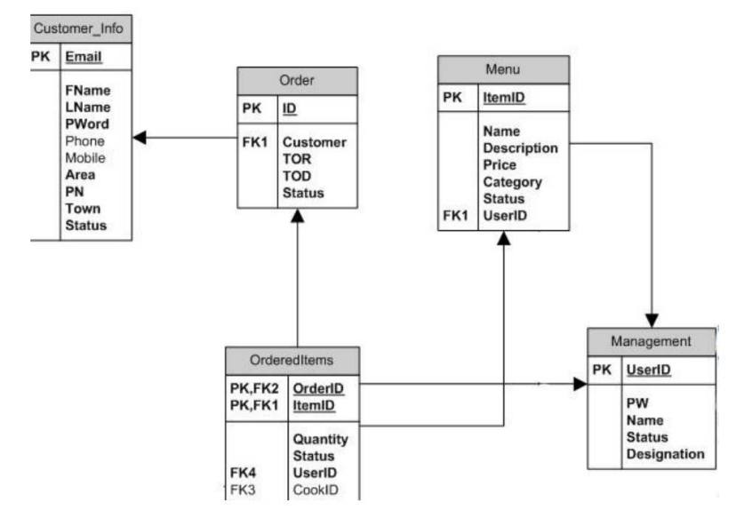

CONCLUSION

With Firebase real-time database, we can build a simple chat application without any single lineof server-side code.The main objective of the project is to develop a Secure Chat Application. Ihad taken a wide range of literature review in order to achieve all the tasks, where I came to knowabout some of the products that are existing in the market. I made a detailed research in that pathto cover the loop holes that existing systems are facing and to eradicate them in our application.In the process of research I came to know about the latest technologies and different algorithms.There is always some place for enhancements in any software application, however goodand efficient the application may be. Right now, we are dealing withon the instant messaging between the peers. In future the application may further developed to include some featuressuch as 1. Voice messaging. 2. Group calling 3. Live streaming 4. Messages auto delete after agiven time. 5. Personalized message tunes. And a messaging application feature which allowsthe user to create chat room while in conversation with another user by just sending the chatroomname with the hash symbol at the beginning.

